Auto-pay Payment Arrangement Step-by-step Guide
Auto-pay (formerly known as ZOOM/ Express Pay) is a payment arrangement that offers you the convenience to pay your bills without queuing and waiting at your last stop of service.
Application for Auto-Pay
1. | You may sign up for Auto-Pay via:  - Your HealthHub account through the HealthHub App or at www.healthub.sg; or  - NUHS app (under Payment >> Other Enquiries >> Sign up for Auto-Pay)
2. | After logging into your HealthHub Account:  - Navigate to the Payments & Financials page  - Select Auto-pay setup. | 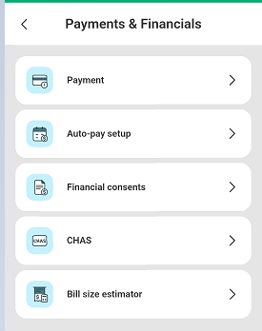
3. | - As the Payer, you can Add New Auto-pay Payment Arrangement for your family members, friends and yourself.  - View existing Auto-pay set-ups and make changes easily. | 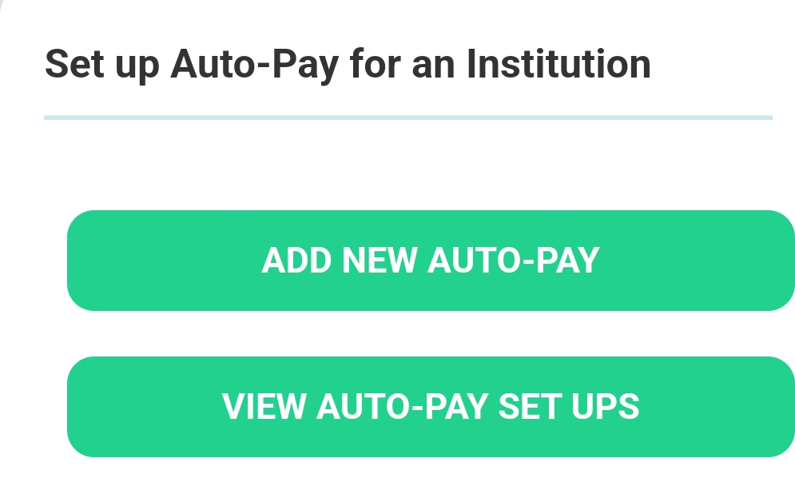
4. | - Select the institution of your choice.  (National University Hospital / Jurong Health Campus)  - Input your particulars as the Payor. (Contact details is strictly for Auto-pay set-up correspondences. This will not update your details registered with the Institution.)  - Select Payee / Patient - You may select from the list of dependents or Manually Add a new Payee not in the list. | 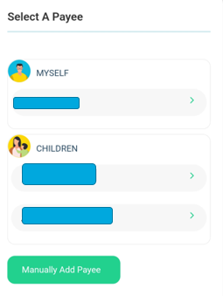
7. | You may choose to set a limit for specific bill types. However, you would need to pay for the excess separately. | 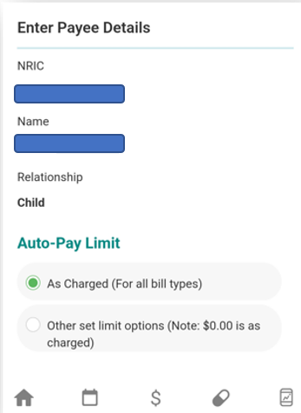
8. | After confirming your desired set-up, please input your Card details into the Secured Payment Gateway and perform the verification through your card issuer. | 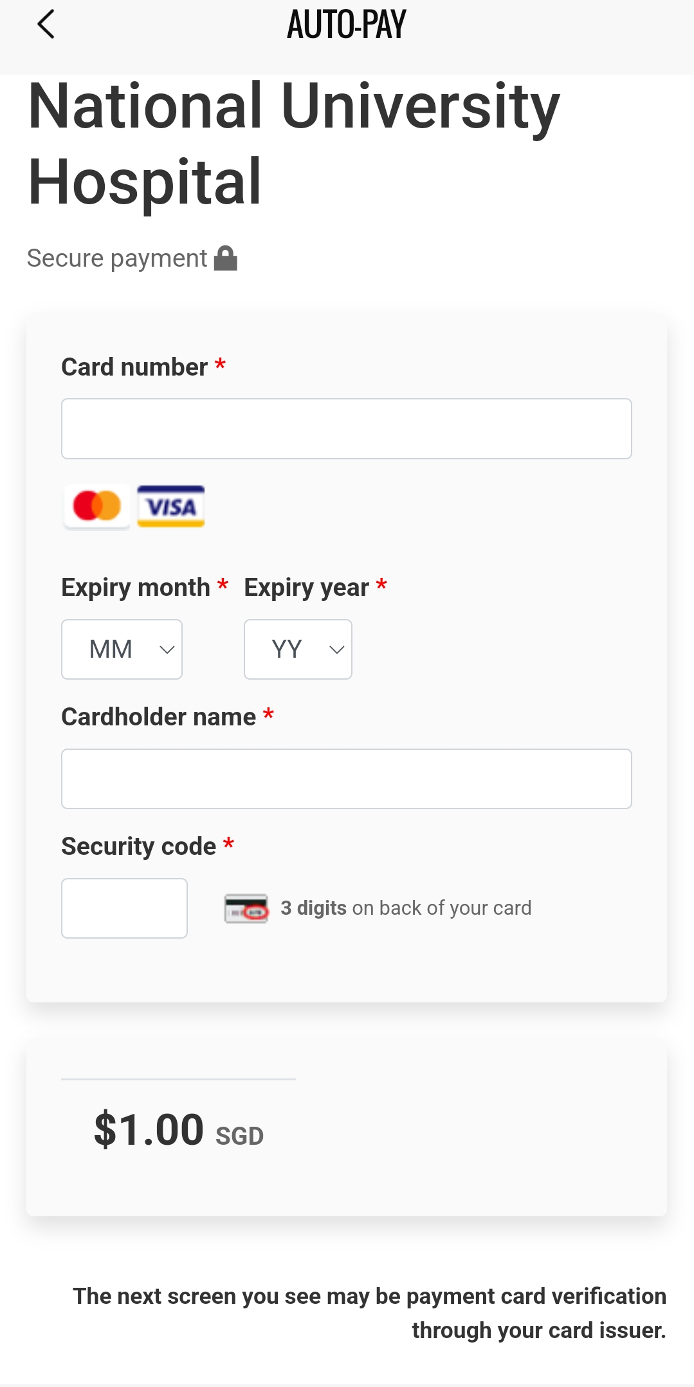
 | Congratulations! You have successfully set-up your Auto-pay Payment Arrangement. | 